The seminar on "Code Your Future: Careers in Web Development,"

NDUB campus on Tuesday, 27th May 2025 was filled with life as students attended Room No. 512 to attend an interactive seminar labeled "Code Your Future: Careers in Web Development." Hosted by the NDUB Computer Club, the seminar aimed at offering students from all areas of study an opportunity to learn more about the numerous web development careers.

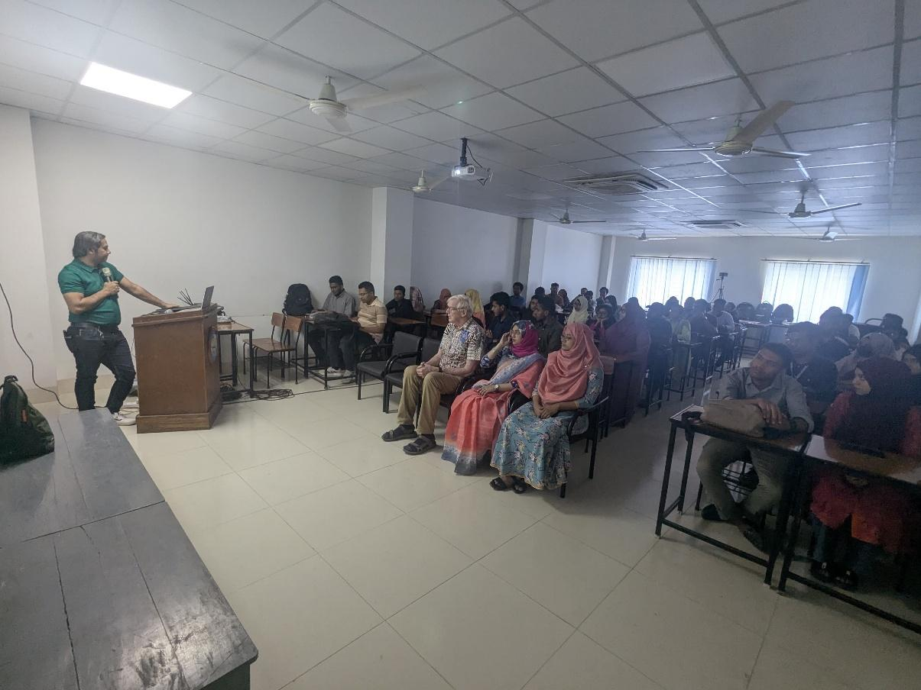

Students from all departments filled the room as the seminar commenced on time at 12:30 PM, which reflected the open character of the event. Web development, which had previously been a technical niche profession, was presented as an open and thrilling career prospect for somebody keen, interested, and eager to learn.

**Highlights and the Keynote Speaker**:

Astha IT Vice President of Engineering Khurshaduzzaman Razib was the keynote speaker and guest of honor of the seminar. Apart from giving comments on the technical side of web development, Mr. Razib has also narrated his own experience regarding technology in a muted but meaningful manner. He acknowledged the culture of continuous learning, asking questions, and leveraging the expanding opportunities presented by the digital world.

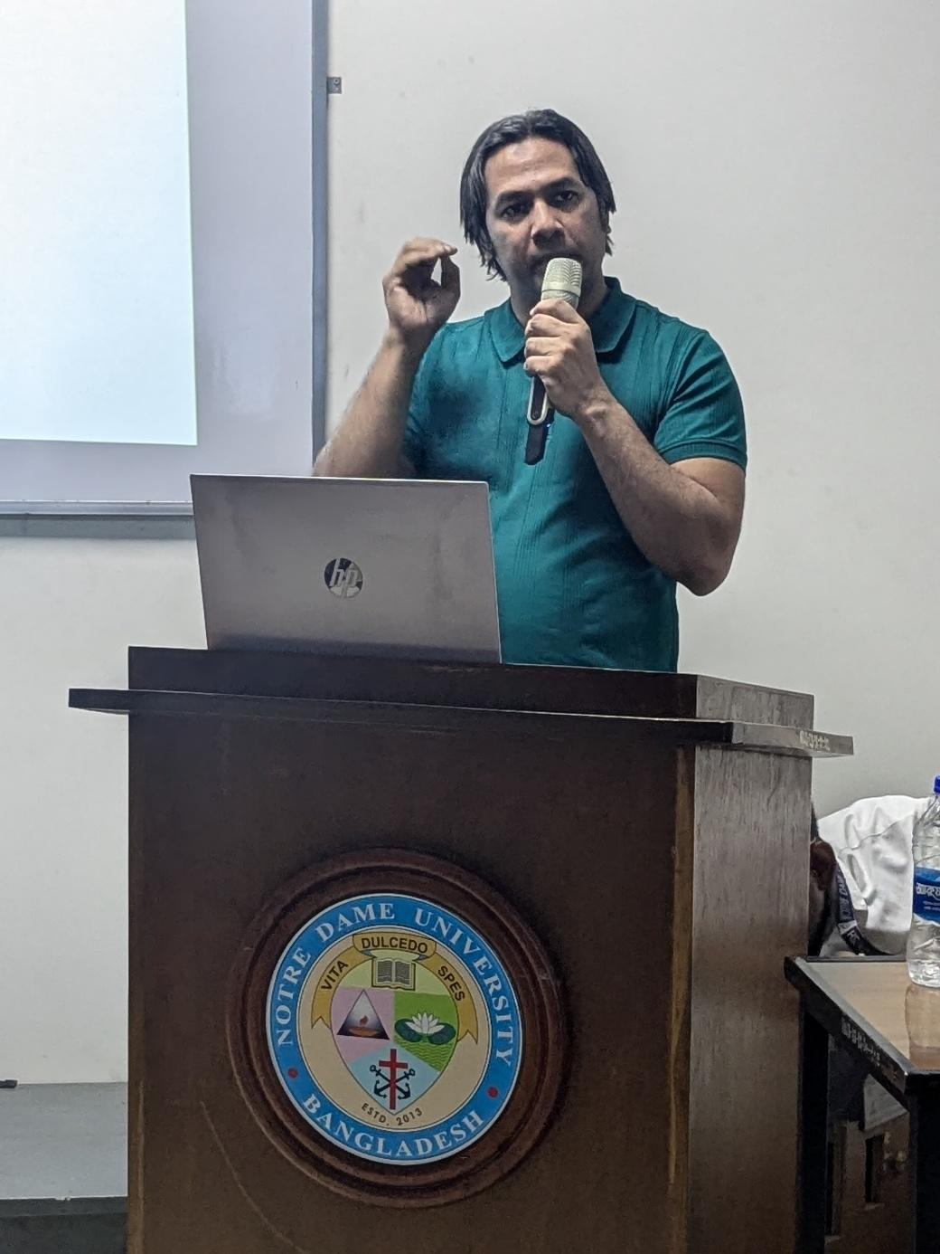

His message of openness, in which he promised the people that anyone could be taught to code and have a successful web development career no matter their educational background, was the key to his success. He made abstract ideas concrete by presenting them in tangible forms that anyone could understand, making the students interested and sure.

**Distinguished Guests and Words of Inspiration:**

Dr. Fr. Patrick Daniel Gaffney, CSC, vice chancellor, whose warm presence and commanding oration made a lasting impression. His sponsorship of the students' activity and his belief in the prospective destinies of young minds was a resounding declaration of the significance of the seminar.

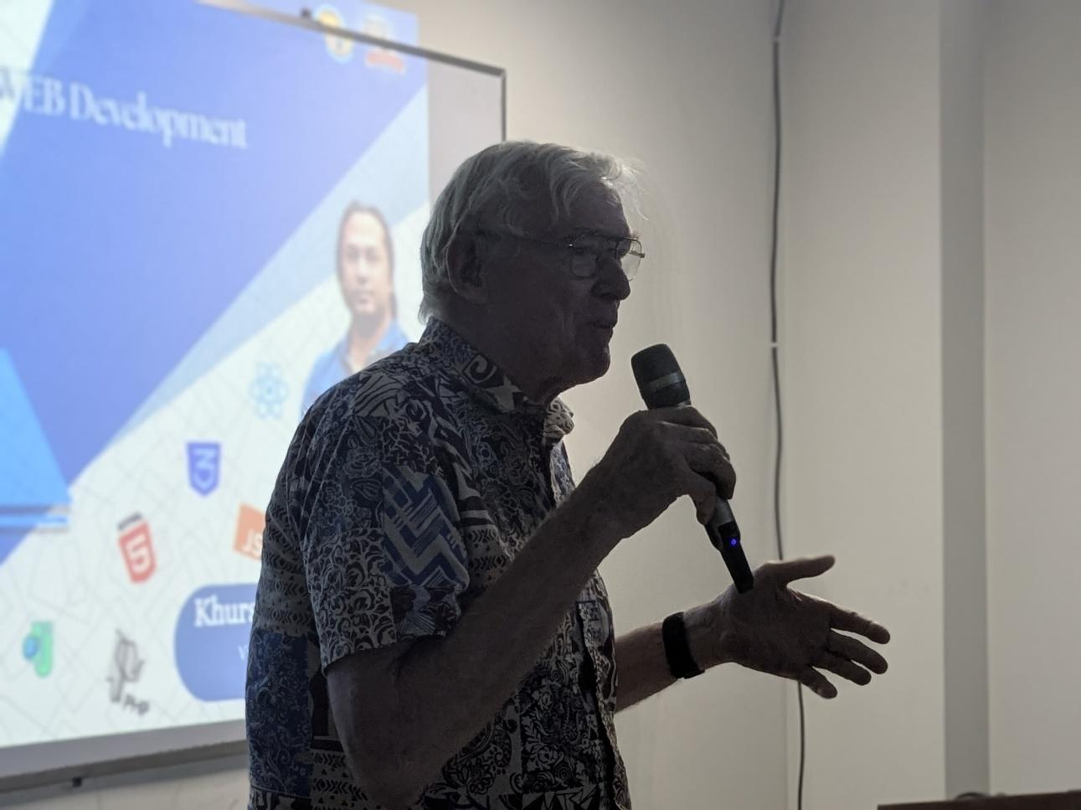

The session was further supplemented by the presence of A. H. M. Saiful Islam, Moderator, NDUB Computer Club and Co-moderator Nafisa Tabassum. It was obvious that one could see their dedication to arranging such a thought-provoking seminar open to every second of the event—from participation to careful speaker selection.

Co-moderator and the moderator arrived on the stage near the end of the seminar in order to express a few words. They were grateful to the energy of the students and requested them to keep up the self-improvement and ongoing learning. Their statement was real, heartfelt, and inspiring.

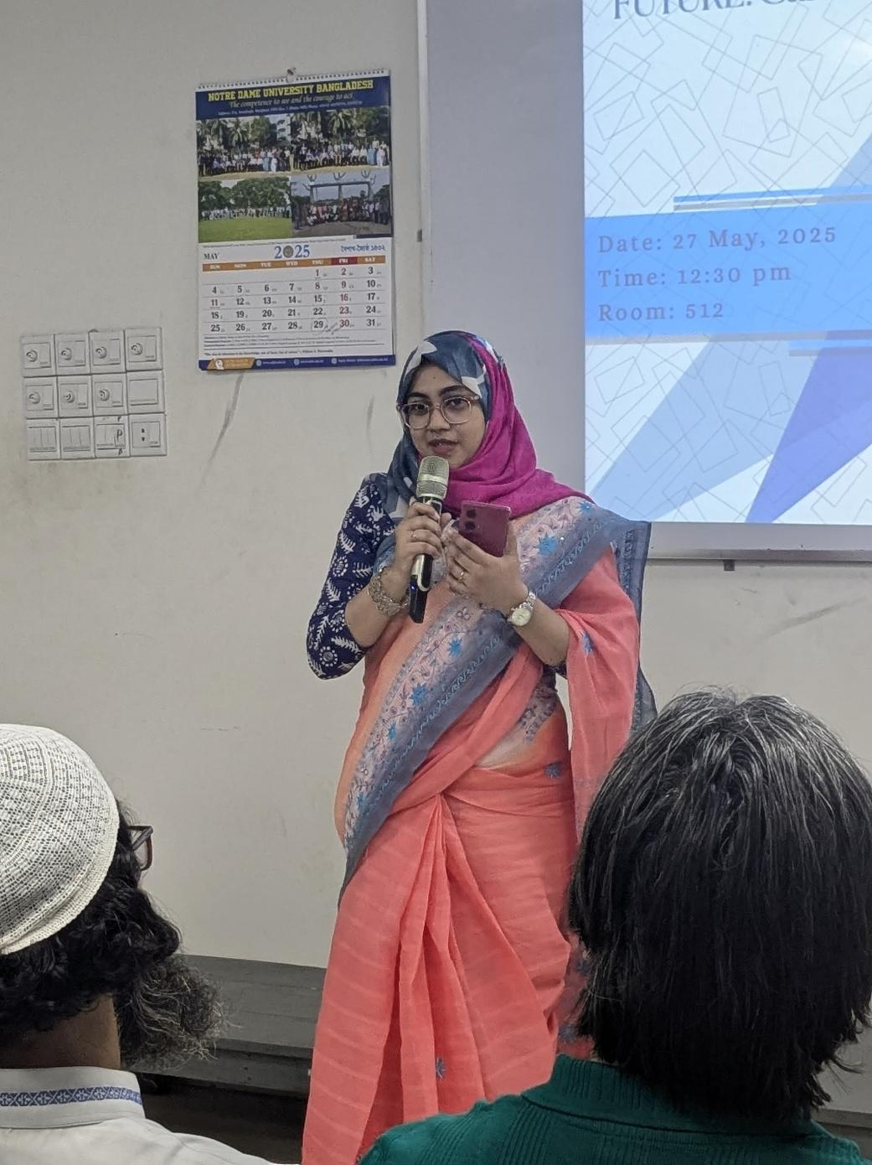

The seminar concluded on a note of inspiration with a speech from Dr. Fr. Patrick Daniel Gaffney connecting technology with service, meaning, and personal transformation. His message was an eye-opener to all that success is not so much about skills, but about integrity, effort, and vision.

**A Grateful Ending:**

As a gesture of appreciation, Dr. Fr. Patrick Daniel Gaffney, CSC, gifted a souvenir to Mr. Khurshaduzzaman Razib himself for his time, commitment, and expertise that he invested in mentoring the future developers. The gesture reflected NDUB's collaborative and appreciative nature.

The seminar concluded in the spirit of warm discussion, energized minds, and heightened awareness of possibilities. Students departed not only with newfound information but with an awareness that their future in technology—and far more particularly, web development—could begin with one step: experimentation.

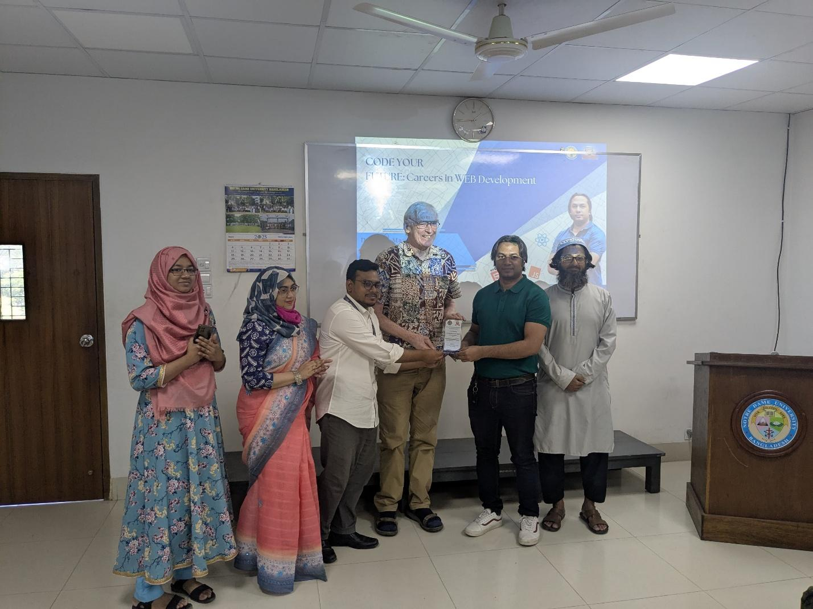

**Conclusion**:

"Code Your Future: Careers in Web Development" was not a seminar. It was an eye-opener for the majority of the students who had finally understood that their technical aspirations were real. With the motivational talk of the speakers and the tireless efforts of the organizer’s day and night, the event made a lasting impression on all the individuals who attended it. The seminar was concluded with an inspirational talk by Dr. Fr. Patrick Daniel Gaffney, CSC that connected technology to service, meaning, and personal transformation. His message was a reminder to everyone in attendance that success is less an issue of skills, but of integrity, work, and vision.